**BARCODE USING IN PARAMETER**

1. First attached value in parameter or variable
2. In Object library select barcodes then assign a binding

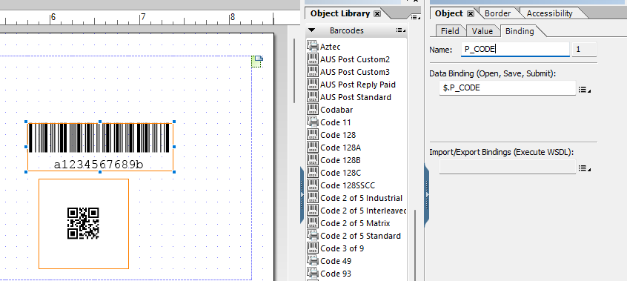

1. To remove the number or character below barcode select field tab then select none for location

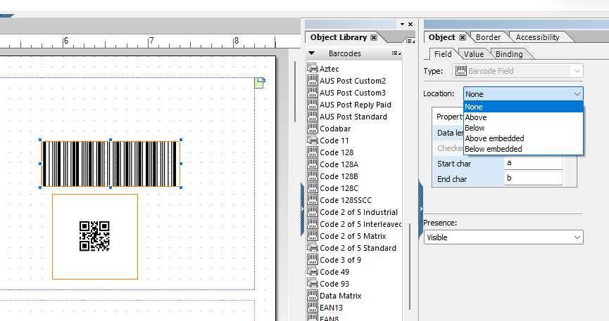

**BARCODE IN TABLE**

1. Just bind the field required for barcode

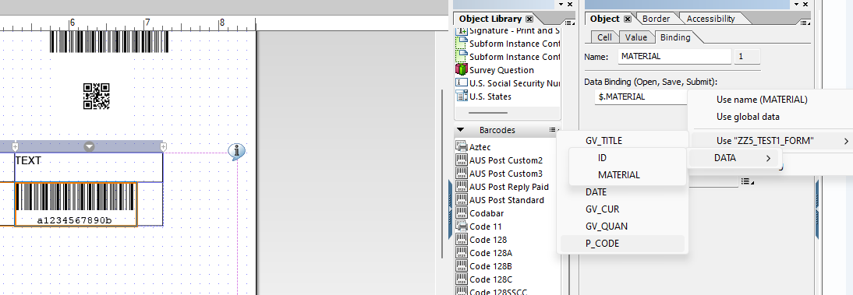

1. If there is an error about border simply click the border for that specific cell and make it none

